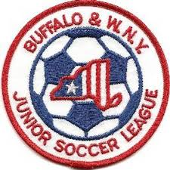 Buffalo & Western New York
Junior Soccer League
Board of Directors Meeting
December 10, 2018
6:00 PM
- Finalize 2019 Play Dates
- Website - 2019 Update – Bob L. & Michele L.
    - Design
    - Populating Data
    - League Season Registration
    - Odenbach Registration
- Finance Report:
a) IRS Update
b) Other Issues Outstanding
- Referee Report – John K.
- S. Tier Storm Update
- Review Revised P&P
- Other
- Adjournment

