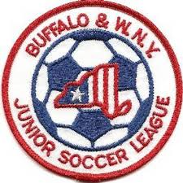Buffalo & Western New York
Junior Soccer League
Board of Directors Meeting
December 2, 2019
6:00 PM
Section I – General Matters

- Finance Reports –
a) Treasurer's Report – Neal S.
b) Worker’s Comp Update – Bob L.
c) Clubs still owing 2019 Fees (if any)
- Clubs deemed to be in “Bad Standing”
- 2020 Odenbach
a) Final Setting of Registration Fee
- Demosphere & Website Update – Bob L.
- NYSWYSA AGM Meeting Update – Bob L.
- Project Play Update – Bob L.
Section II – Governance Matters

Section III – General Policy Issues
1. Update on Amherst-Williamsville Club matters
2. Update on Lackawanna Club matters
3. Policy & Procedure Revamp to match new website, operations
4. Number of Teams – Caps, limits on number per club or age group

5. Fields needed to register teams-Discussion on deadline for securing fields by clubs
6. Alignment Committee Members
  - U8-U12 Dates: 2/8-2/15, Preliminary Cmte. Meeting Appeal Mtg. 2/29
  - U13-U19Dates: 3/8-3/15, Preliminary Cmte. Meeting Appeal Mtg. 3/29
- Roster Freeze Dates-FINAL
  - U8-U12 Rosters frozen 11:59PM 5/15/2020
  - U13-U19 Rosters frozen 11:59PM 6/15/2020
- Reschedule Issues – Limited as currently in P&P, none considered after 11:59 PM on
5/15/20 for U8-U12, after 11:59 PM on 6/15/20 for U13-U19

- Future of Dual Carding

Adjournment
Upcoming Board Meetings
January 20, 2020 March 30, 2020 May, 2020 July, 2020 September, 2020
Upcoming League Meetings
February 3, 2020 April 27, 2020 August 10, 2020 October 5, 2020 (AGM)

