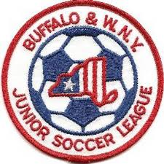Buffalo & Western New York
Junior Soccer League
Board of Directors Meeting
October 28, 2019
8:00 PM
Section I – General Matters

- Finance Reports –
a) Treasurer's Report – Neal S.
b) Worker’s Comp Update – Bob L.
c) Clubs still owing 2019 Registration Fees (if any)
- 2020 Odenbach
- Website – Bob L.
- Demosphere Update – Bob L.
- NYSWYSA Update – Bob L.
- Project Play Update – Bob L.
Section II – Governance Matters

- Board Member Assignments for 2019-2020
  - Player Eligibility-Michele L. & Ken V.
  - Alignments-Michele L. & Marty O.
  - Discipline-Steve W. & Chuck M. on players, Steve W., Neal S. & Bob L. coaches

Section III – General Policy Issues
1. Amherst-Williamsville Club matters
2. Lackawanna Club matters
3. Policy & Procedure Revamp to match new website, operations
4. Number of Teams – Caps, limits on number per club or age group
5. Fields needed to register teams
6. Alignment Meetings
  - U8-U12 Dates: 2/8-2/15, Preliminary Cmte. Meeting Appeal Mtg. 2/29
  - U13-U19Dates: 3/8-3/15, Preliminary Cmte. Meeting Appeal Mtg. 3/29
- Roster Freeze Dates
  - U8-U12 Rosters frozen 11:59PM 5/15/2020
  - U13-U19 Rosters frozen 11:59PM 6/15/2020
- Reschedule Issues – Limit, eliminate
- Future of Dual Carding
- Pre-game Handshake vs. post game
Adjournment
Upcoming Board Meetings
December 2, 2019 January 20, 2020 March 30, 2020
Upcoming League Meetings
February 3, 2020 April 27, 2020 August 10, 2020 October 5, 2020 (AGM)

