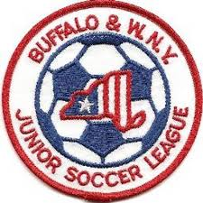Buffalo & Western New York
Junior Soccer League
League Information Meeting
August 12, 2019

Roll Call of Member Representatives

Treasurer’s Report
Recognition and Reports of Related Organizations

District Commissioner-NYSWYSA Buffalo Referee Unit
Upstate Women’s League Epic Center
Buffalo District Soccer League Other

League Reports

1. 2019 Odenbach Tournament Review
2. 2019 Preliminary Season Review
3. 2019 Preliminary Discipline Review
3. 2020 Preliminary Potential Changes
4. 2019 Awards

Corporate Governance Matters

1. Board Vacancy
2. Upcoming Elections for Vice President, Secretary and Trustee
2. NYS Workers Comp Issues
3. Non-Member Club team participation/registration for League play
4. US Club Soccer
Adjournment

Next Meeting: Annual General Meeting Monday, October 21, 2019 7:30 PM

