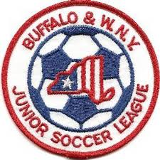Buffalo & Western New York
Junior Soccer League
Board of Directors Meeting
January 20, 2020
6:00 PM
Section I – General Matters

- Finance Reports –
a) Treasurer's Report – Neal S.
b) Budget 2019-2020
c) Worker’s Comp Update – Bob L.
- d) Clubs still owing 2019 Fees (if any)
- 2020 Odenbach
- Final Setting of Registration Fee
- Registration to Open March 15th after alignments are posted
- Demosphere & Website Update – Bob L.
- Registrations progressing via NYSW RosterPro
- Embedding of Forms commencing with Team Registration Data Form-more to come
- Project Play Update – Bob L.
a) Next meeting Jan. 21, 2020
Section II – Governance Matters

- Conflict of Interest and Non-Disclosure forms

- Tax Returns update

- Additional items to post on website

Section III – General Policy Issues
1. Update on Amherst-Williamsville Club matters
2. Policy & Procedure Revamped to match new website, operations-Posted at website
3. Alignment Committee Members
  - U8-U12 Dates: 2/8-2/15, Preliminary Cmte. Meeting Appeal Mtg. 2/29
  - U13-U19Dates: 3/8-3/15, Preliminary Cmte. Meeting Appeal Mtg. 3/29
  - Discussion on Location, logistics and members
- Referee Presentation of Rule Changes
- Other Matters to discuss at League Information Meeting on February 3, 2020
- Good of the Order

Adjournment

Upcoming Board Meetings
March 30, 2020 May, 2020 July, 2020 September, 2020
Upcoming League Meetings
February 3, 2020 April 27, 2020 August 10, 2020 October 5, 2020 (AGM)

