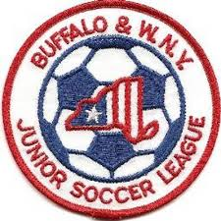Buffalo & Western New York
Junior Soccer League
League Information Meeting
February 3, 2020

Roll Call of Member Representatives

Treasurer’s Report
Recognition and Reports of Related Organizations

District Commissioner-NYSWYSA Buffalo Referee Unit-Laws of the Game Update
Upstate Women’s League Indoor Facilities
Buffalo District Soccer League Other

League Reports

1. 2020 Fees-Same Structure as 2019-see website
2. 2020 Policies and Procedures Posted on website
3. Registration Update-Michele Letina
4. Roster Size Limits, Eligibility Issues and Roster Freeze Dates
5. Naming Conventions
6. Team Alignments-Review of process and appeal meeting dates
7. Field Permits
8. 2020 Odenbach Tournament Report-Neal Smith
9. Game Reschedules-Limits and Deadlines
10. Positive Coaching program
11. U8(2012) for 2020, U9(2012) for 2021

Corporate Governance Matters

1. Draft Minutes of Annual General Meeting 9-30-19
2. Updated Contact Information
3. NYS Workers Comp Issues Update
4. NYSWYSA Annual General Meeting Report
5. Project Play Update-Next Community Conversation March 28, 2020
6. US Club Soccer
Adjournment

Next League Information Meeting: Monday, April 27, 2020 7:30 PM

