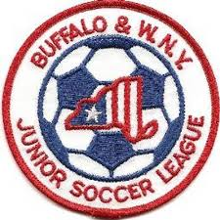Buffalo & Western New York
Junior Soccer League
League Information Meeting
April 26, 2021

Roll Call of Member Representatives

Treasurer’s Report
Recognition and Reports of Related Organizations

District Commissioner-NYSWYSA Buffalo Referee Unit
Upstate Women’s League Epic Center
Buffalo District Soccer League Other

League Reports

1. Rosters and Risk Management Issues
2. Registration Report
3. Field Issues
4. U10 players retreat line review
5. Game Reschedules-None for 2021 except for weather related matters
6. Score Reporting
7. U10-12 Schedules
8. U13-19 Alignments & Schedules
9. Odenbach Tournament-Cancelled for 2021

Corporate Governance Matters

1. 2021 Board Member Terms Expiring-Vice President, Secretary, Trustee 1 (2yr. term)
2. Non-Member Club team participation/registration for League play

Adjournment

Next Meeting: Monday, August 9, 2021 7:30 PM

